.

Date:29.10.25
TASK:12

Implementation of AI-CHATBOT FOR FARMERS
CO4, CO5 S3

PROBLEM STATEMENT :
Farmers often face challenges in obtaining timely and accurate information related to crop management, weather forecasts, pest control, and government schemes. There is a need for an intelligent system that can assist farmers through automated, easy-to-use communication.

AIM :

To develop an AI-based chatbot that provides farmers with instant and relevant agricultural information using natural language processing and knowledge-based responses.

OBJECTIVE :
- To design an interactive chatbot that can understand farmers’ queries in simple language.
- To provide accurate information about crops, weather, fertilizers, and farming techniques.
- To assist farmers with government schemes and market price updates.
- To demonstrate the use of artificial intelligence for improving agricultural decision-making.

DESCRIPTION :
The AI Chatbot for Farmers uses NLP (Natural Language Processing) techniques to interpret user queries and respond with appropriate agricultural advice. It acts as a virtual assistant, helping farmers with weather updates, pest control measures, and crop management tips. The chatbot can be deployed on mobile or web platforms, ensuring accessibility for rural communities. This system showcases how AI can support smart farming and enhance agricultural productivity.

ALGORITHM :
- Start the chatbot and display a welcome message to the user (farmer).
- Accept the user’s query as text input.
- Analyze the query by checking for specific keywords like weather, fertilizer, pest, or scheme.
- Respond with an appropriate predefined message based on the identified keyword.
- Repeat the process until the user types “exit”, then display a goodbye message and stop the program.

PROGRAM :
# Simple AI Chatbot for Farmers
# Using basic keyword-based response system

def farmer_chatbot():
print(" AI FARMER CHATBOT: Hello! How can I help you today?")
print("Type 'exit' to end the chat.\n")

while True:
query = input("‍ You: ").lower()

if "weather" in query:
print(" Chatbot: Today's weather is sunny with moderate temperature. Ideal for fieldwork.")
elif "fertilizer" in query:
print(" Chatbot: Use nitrogen-rich fertilizer like urea for better crop growth.")
elif "pest" in query or "insect" in query:
print(" Chatbot: Try using organic neem oil spray to control pests effectively.")
elif "crop" in query:
print(" Chatbot: Wheat and maize are good choices for this season based on soil fertility.")
elif "scheme" in query or "government" in query:
print(" Chatbot: You can apply for the PM-KISAN Yojana for financial support.")
elif query == "exit":
print(" Chatbot: Goodbye! Wishing you a great harvest ahead!")
break
else:
print(" Chatbot: Sorry, I didn't understand. Please ask about weather, crops, or fertilizers.")
farmer_chatbot()

OUTPUT :

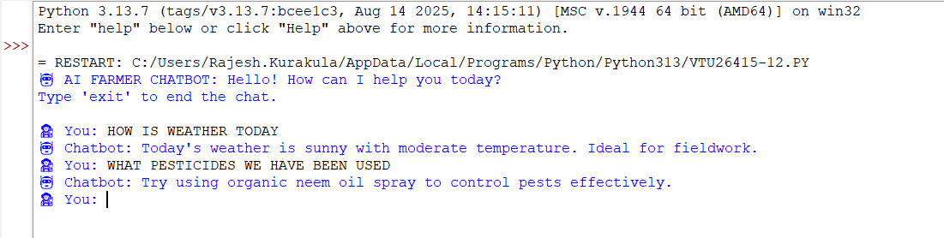

CONCLUSION:

The AI Chatbot successfully interacts with farmers, answering their queries about crops, fertilizers, weather, and government schemes. It demonstrates how artificial intelligence can enhance agricultural communication, provide timely support, and assist in decision-making for better productivity.

